**BATTLE OF THE NEIGHBORHOODS**

**Applied Data Science Capstone**

**Background**

Malaysia is a multi-ethnic and multi-cultural country, part of South East Asia with the largest population consists of Malay, Chinese and Indian. Chinese population is the second largest ethnic in Malaysia, as such there is high opportunity to invest in the Chinese restaurant business.

**Problem Statement**

The question here is how entrepreneurs can find the best locations (Kuala Lumpur or Penang) in Malaysia to open a Chinese restaurant. I will take into consideration two main factors for the location selection:

1. Chinese population by states
2. Total restaurant in the state

**Data**

1. The Foursquare location data will be used to explore the restaurant in Kuala Lumpur and Penang, in order to get the total restaurant in both states.
2. Use Geocoder API to extract longitude, latitude coordinates.
3. I will scrap the Wikipedia to derive the Malaysia demographic data.

Data source:

Wikipedia Malaysia postal code

https://ms.wikipedia.org/wiki/Senarai_poskod_di_Malaysia

Foursquare categories of Restaurant

<https://developer.foursquare.com/docs/resources/categories>

Malaysia demographic

Source: National Census 2010, Department of Statistics Malaysia

**Target Audience**

Entrepreneurs who are planning to open a new restaurant in Malaysia’s two main states Kuala Lumpur and Penang.

**Methodology**

**Step 1 – Business Understanding**

The goal is to create a profile of restaurants in both Kuala Lumpur and Penang. This profile will be the reference point for entrepreneurs who would like to open a restaurant business.

**Step 2 – Data Requirement**

As mentioned above section, data are collected from Wikipedia, Foursquare and Department of statistics Malaysia.

**Step 3 – Data Analysis**

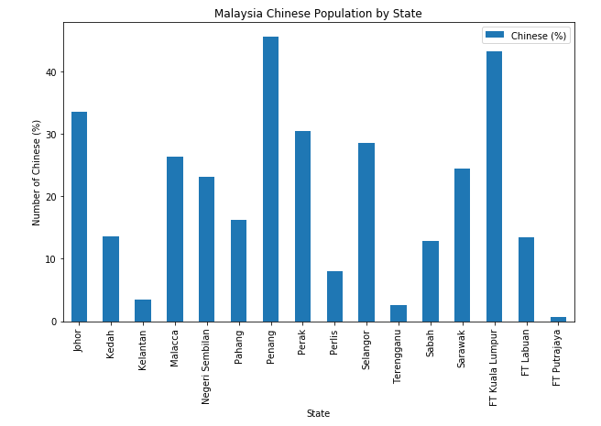

Above Bar graph shown that two states with highest percentage of Chinese population are Penang and Kuala Lumpur. Both are having more than 50% of Chinese.

Neighborhoods of Kuala Lumpur by Post Code

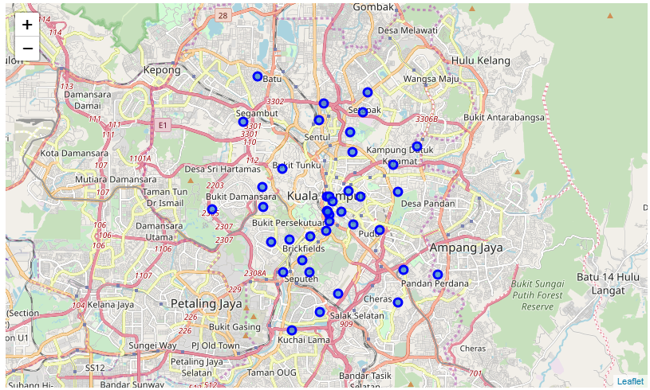

Coordinates of Kuala Lumpur by Post Code

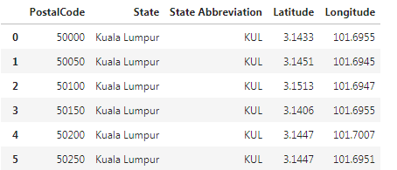

Neighborhoods of Penang by Post Code

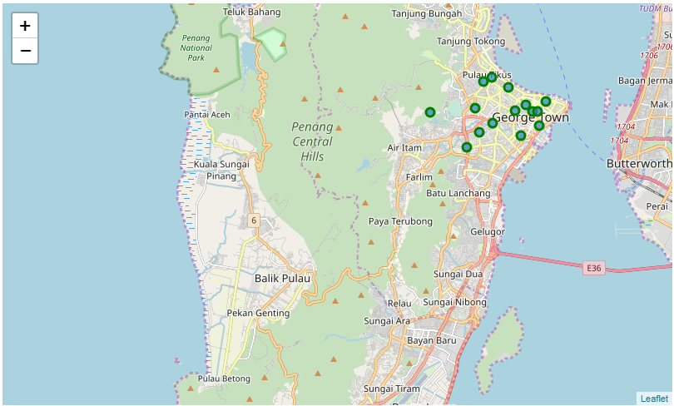

Coordinates of Penang by Post Code

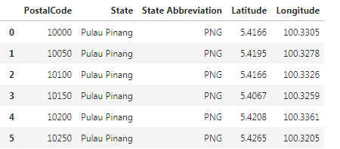

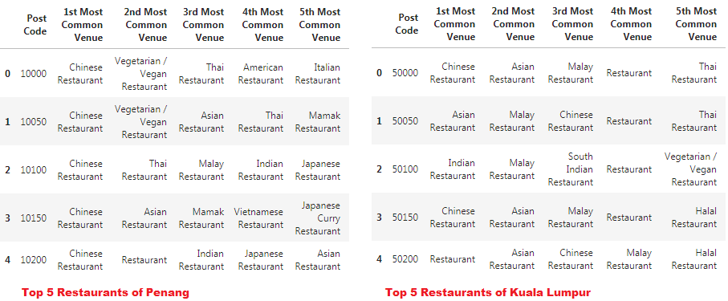

Based on above table, residents of Penang prefer Chinese restaurant as their top choice, whereas Kuala Lumpur residents has a more varieties of taste by different Post Code/Area.

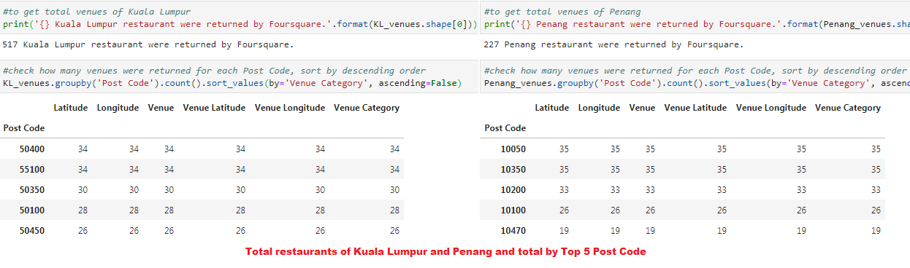

Kuala Lumpur is having total of 517 restaurants compare to Penang only has 227 which is less than 50% of Kuala Lumpur.

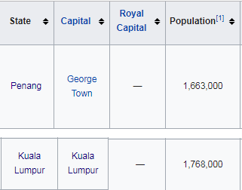

However, looking at the total population of Kuala Lumpur which is higher than Penang, there is still potential to setup a restaurant there.

**Discussion**

In this study, I analyzed the neighborhoods of Kuala Lumpur and Penang by Post Code. By using the Foursquare API, I derived the nearby restaurants of each Post Codes for further analysis. It is recommended to open Chinese restaurant in either Kuala Lumpur or Penang, looking at the high population of Chinese residents in both States.

Kuala Lumpur is having more restaurants compare to Penang. This is due to the bigger land area of Kuala Lumpur and there is still potential business to open a new restaurant in Kuala Lumpur.

**Conclusion**

Based on the analysis, it is recommended to open a new restaurant in Kuala Lumpur.